Technology Deep-Dive Document

1. Context and Problem Statement
The Lal Kitab Astro-Tech Remedy Platform addresses a persistent gap: people often know the remedies prescribed in Lal Kitab but struggle to execute them due to lack of time, logistical challenges, or uncertainty about authenticity. Current spiritual apps lack cultural depth, proof of execution, and personalized guidance. The business problem is therefore threefold: (1) low trust in digital remedy platforms, (2) high failure rates in consistent remedy execution, and (3) limited scalability of offline consultation models.
To solve this, the platform will adopt Generative AI and Retrieval-Augmented Generation (RAG)-powered agents to personalize guidance, automate remedy scheduling, and verify execution through GPS-stamped photo/video proof. This emerging technology provides culturally aligned, contextually aware, and scalable support, creating a new trust benchmark for the sector.

2. Technology Landscape
Emerging technologies relevant to this model include:
- Generative AI: for natural language consultations and personalized guidance.
- RAG-powered agents: enabling contextual responses from authentic Lal Kitab knowledge bases.
- IoT and GPS tagging: verifying ritual execution with geo-stamped media.
- Cloud-native mobile platforms: ensuring scalability and accessibility.
Current competitors (such as generic astrology apps) lack verified execution mechanisms and robust personalization. This platform differentiates itself by combining traditional trust anchors with cutting-edge AI and proof systems.

3. Proposed Architecture
The architecture consists of:
1. Mobile App (front-end) – Remedy scheduling, alerts, media uploads, multi-user family tracking.
2. AI Agent Layer – GenAI + RAG agents trained on Lal Kitab knowledge, guiding users contextually.
3. Verification Engine – GPS, timestamp, and photo/video proof validation.
4. Cloud Backend – Manages subscriptions, data storage, compliance with DPDP Act 2023.
5. Admin/Dashboard – For astrologers and pandits to review logs, coach clients, and manage remedies.
This modular design supports a Hyderabad pilot, with scope to scale nationally and license as SaaS.
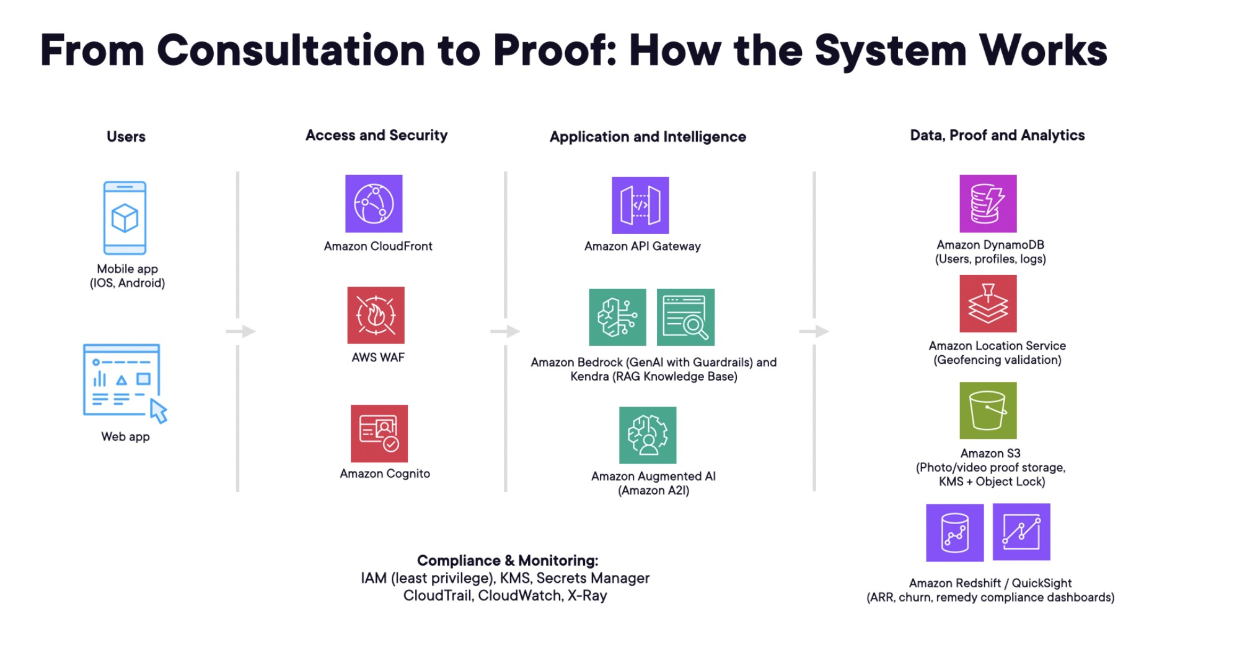

4. Risks and Mitigation
- Technical Risk: AI hallucinations → Mitigation: RAG with curated Lal Kitab corpus.
- Operational Risk: Delivery agent dropouts → Mitigation: backup logistics partners (Rapido/Dunzo).
- Data Privacy Risk: User consent and misuse of ritual data → Mitigation: strict DPDP compliance (consent, purpose limitation, data minimization).
- Cultural Risk: Misinterpretation of remedies → Mitigation: advisory board of senior astrologers.
- Financial Risk: Budget overruns → Mitigation: phased rollout, milestone-based spend.

5. Ethical Considerations
The platform must uphold:
- Respect for cultural authenticity, avoiding misrepresentation of Lal Kitab practices.
- Transparency in AI outputs (clear disclaimers, explainability).
- Compliance with the DPDP Act 2023 (consent, storage limits, grievance redressal).
- No medical or false curative claims.
- Ethical training for human agents (astrologers, delivery staff).

6. Future Roadmap
Phase 1 (0–12 months): Hyderabad pilot with 50 paying clients, MVP app, proof-of-execution system.
Phase 2 (12–24 months): Expand to 5 cities, launch certification courses, build franchise model.
Phase 3 (24–36 months): License SaaS backend to other astrologers, introduce diaspora packages.
Phase 4 (36+ months): Launch Astro-integrated CBSE school, complete ecosystem build.

7. Conclusion
By integrating GenAI, RAG, and IoT verification with Lal Kitab traditions, the platform creates a culturally anchored yet technologically advanced remedy execution model. This approach addresses the biggest pain points of trust, consistency, and scalability. With proper safeguards around ethics and data privacy, the Lal Kitab Astro-Tech Remedy Platform can evolve into a bar-raising benchmark for spiritual-tech businesses in India and beyond.

